Mini Project – Spotify Tracks
Objective: A mid-size record label is planning next quarter's signings. They care about one thing:
What kind of music should we be betting on right now?

Dataset: Spotify Tracks and Artists Dataset gotten from kaggle.com
Tool: Python for cleaning and exploration, PowerBi for analysis and storytelling

Data cleaning
I loaded the tracks csv file in my jupyter notebook and began exploration.
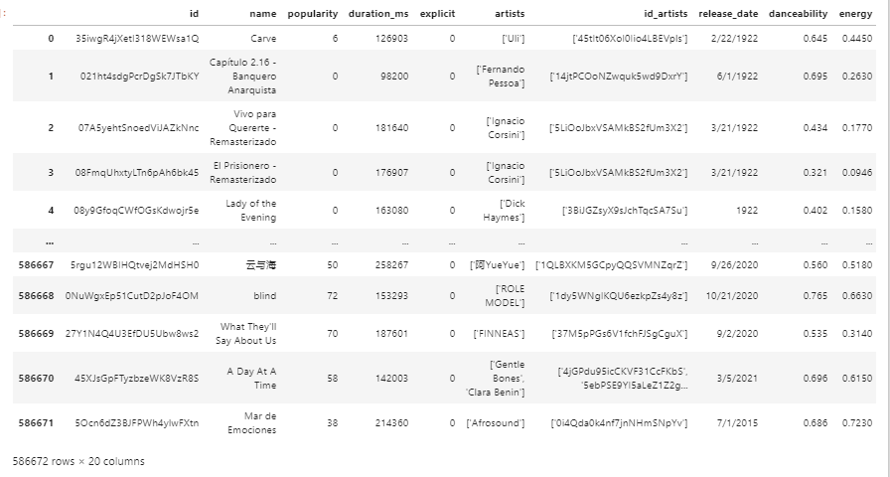
Rows: 586672
Columns: 20
Blanks: 0 null values across all columns
Duplicates: 0 duplicates in unique column (Id)
Outliers: no outliers
Datatypes: String, integer, decimals

- I added a new column [duration_minutes] to convert duration in milliseconds to minutes
- I added a new column [release_date1] to clean and convert release date to date data type
- I rounded up all columns with decimals to 2 decimal places
- I trimmed extra white spaces and made all categorical or string columns title format
- I wanted a genre column so I merged the column genres from another dataset called artists to our current tracks dataset
- For tracks that did not match a genre the genres were left empty so I filled with unknown
- The following columns were not needed anymore "id_artists", "release_date", "name_y","duration_ms. So I dropped them

After cleaning the cleaned dataset had some added rows due to wrangling here and there so I ended up with 647730 Rows and 20 column. For a final touch I dropped all the duplicated rows and ended up with the initial row and column count
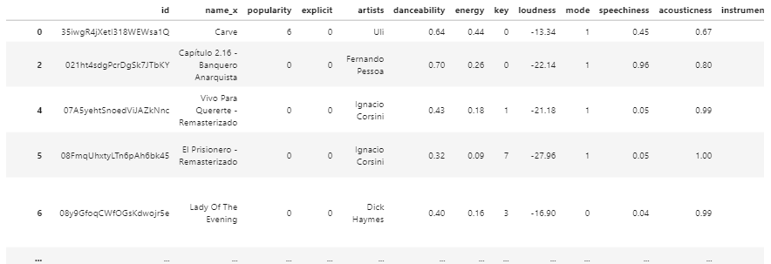

Analysis Approach
After importing the dataset into Power BI, exploratory analysis was carried out to uncover patterns that could inform future artist signings.
- Tracks were grouped into musical eras; Classic, Old School, and the 2000s era to observe how popularity varies across different time periods.
- Instrumentalness was categorized into low and high levels. Low values indicate tracks dominated by vocals, while high values represent tracks with stronger instrumental presence.
- A “Hit Potential” metric was created using danceability and energy to estimate how likely a track is to appeal to a broad audience.
- Track durations were grouped into categories to examine how song length relates to popularity.
- Finally, the top five genres with popularity above the overall average were identified to highlight the styles currently performing best on Spotify.

I finalized with a power bi dashboard which can be found below.

Recommendations
- Focus on Contemporary (Y2K / Modern) Sound
Music from the 2000s era shows the highest popularity compared to older eras.

- Prioritize Vocal-Led Artists
Tracks with strong vocals outperform highly instrumental tracks by a wide margin. Focus on singers and vocal performers rather than instrumental-heavy acts or producers without strong vocal identity.

- Target High-Energy, Danceable Music
Analysis shows that songs with both high energy and high danceability have the strongest hit potential.
- Sign artists capable of producing upbeat, club-friendly, radio-friendly tracks.
- This type of sound typically performs well on streaming platforms such as Spotify.

- Maintain Industry-Standard Song Length
Tracks between roughly 3–5 minutes appear most aligned with popular releases. Encourage artists to produce concise, replayable songs rather than overly long compositions.

- Invest in High-Performing Genres
Through analysis it can be observed that pop song genres thrived the most in performance, this is where we should prioritize while signing.

Conclusion
The analysis suggests that the safest bet right now is modern, vocal-focused music with strong energy and broad appeal. These types of songs consistently attract more listeners and perform better across popular genres. By prioritizing artists who create this style of music, the label can make smarter signings and improve the chances of success in the coming quarter, especially on major streaming platforms like Spotify.

